ASSIGNMENTS

1. Create a remote git hub repository using Git Hub. (you can use any email id for creating)

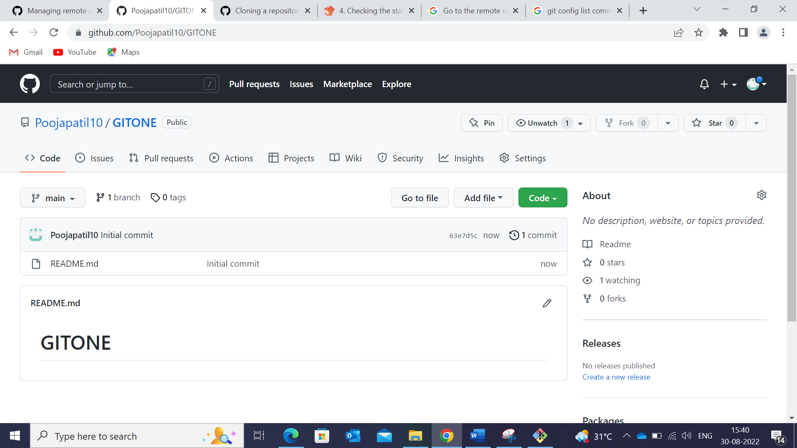

1. Clone the repository on your local machine.

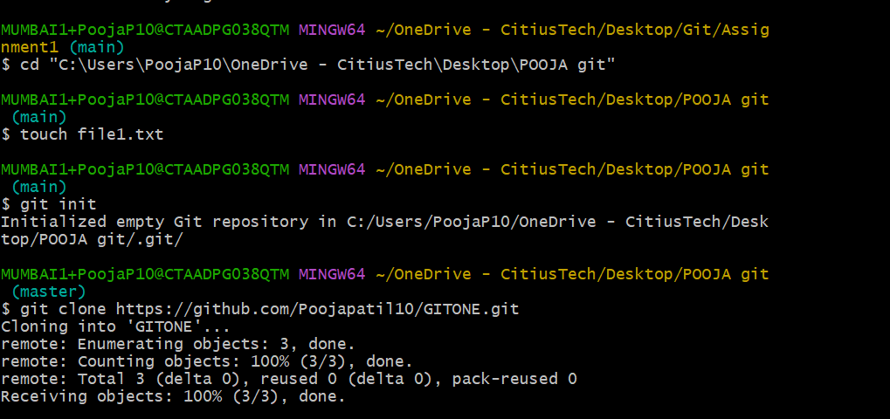

1. Using git config, set the username & email to your name and your CT email id respectively.

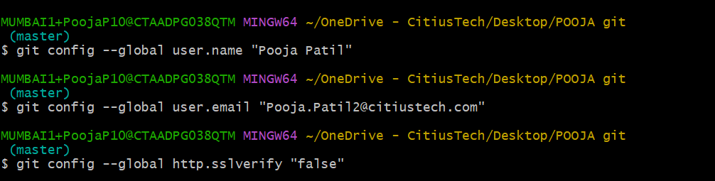

1. Create two empty text files named f1.txt and f2.txt inside the cloned repository.

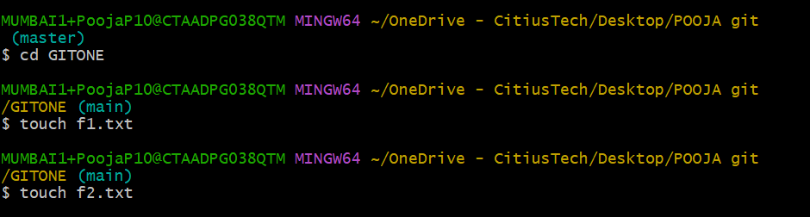

1. Commit and push the changes to the remote repository.

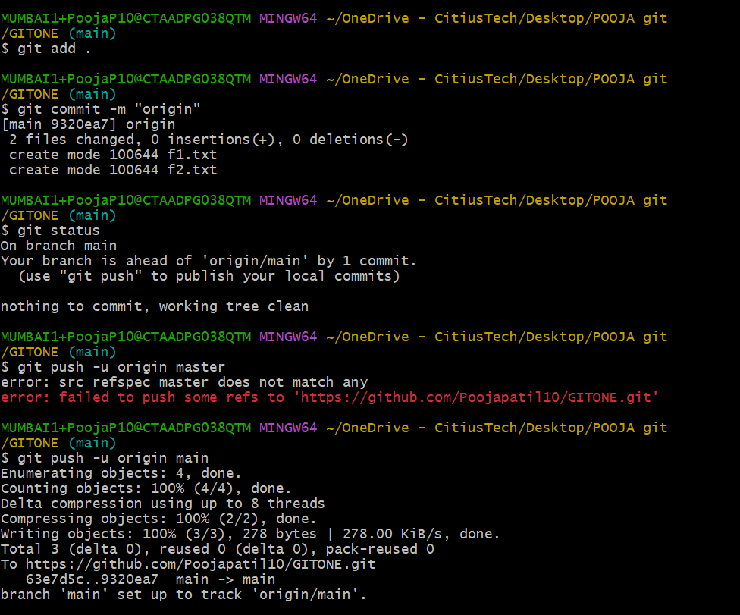

1. Check the status of the local repo.

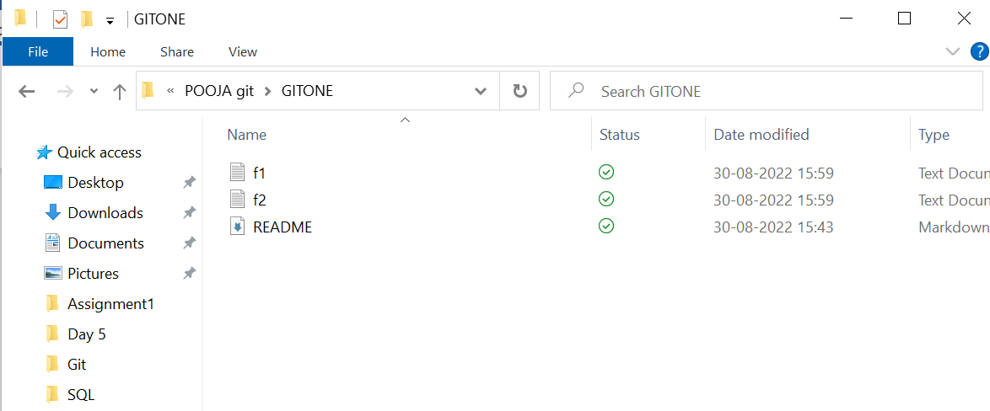

1. Go to the remote repository & check what files are present.

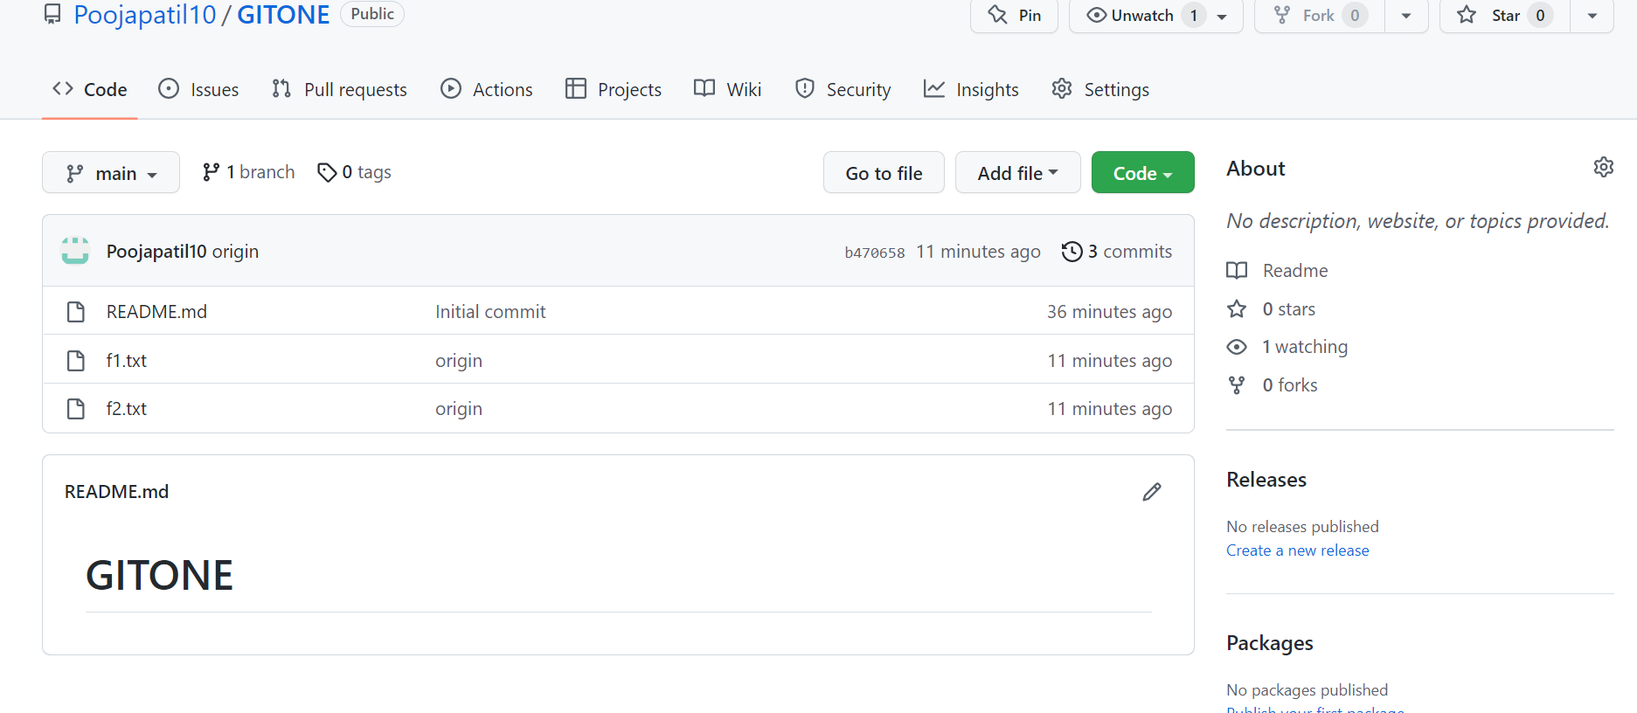

1. Add some text in f2.txt and save the changes.



1. Check the status of the local repo.

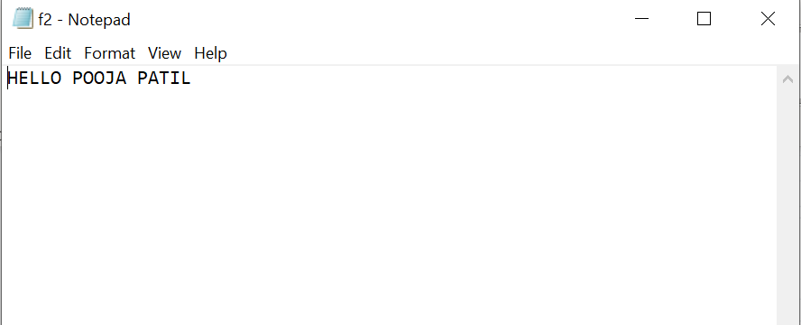

1. Go to the remote repository & check the contents of f2.txt. What do you see and why?

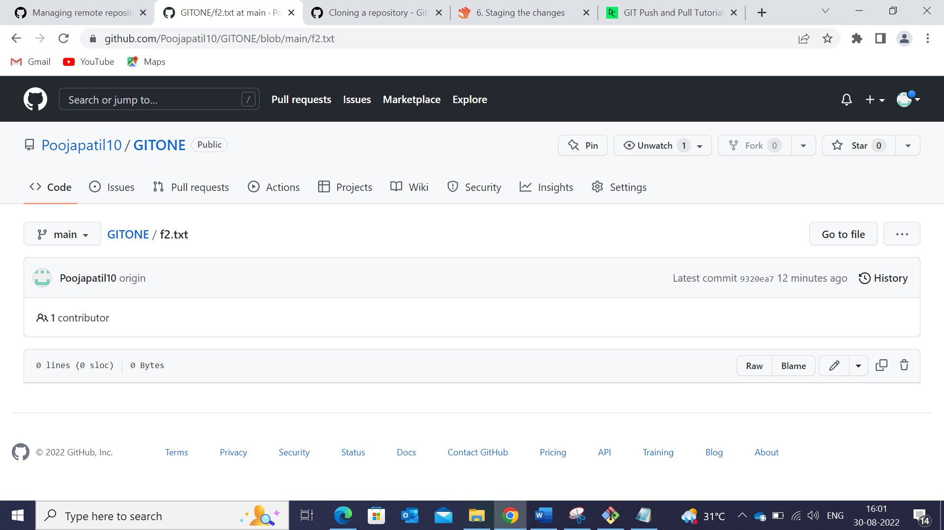

1. Add the file f2.txt into staging.

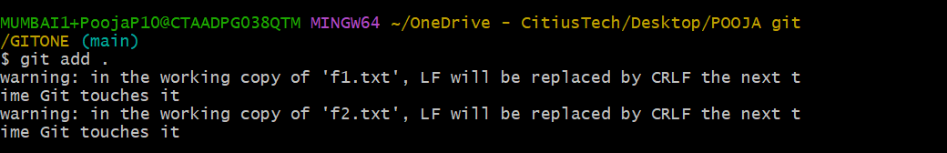

1. Check the status of the local repo.



1. Go to the remote repository & check the contents of f2.txt. What do you see and why?



1. Use appropriate Git commands to push the changes to the remote repository.

